Design Document
for the
Global Support System
Content
1. System Overview 3
2. System Architecture 3
3. Functional Module Designs 3
4. Database Design (Simplified ERD) 5
5. User Interface Design 6
5.1. Templates Rendered with EJS 6
5.2. UI Features 6
6. Permissions Model 6
7. Design Considerations 7
7.1. Security 7
7.2. Scalability 7
7.3. Usability 7
7.4. Maintainability 7

System Overview
The Global Support System (GSS) is a modular web application designed to manage logistical and operational support services such as asset tracking, bicycle rentals, laundry management and accommodation assignments. It serves field personnel through both web and mobile (APK) interfaces, offering real-time, secure, and role-based access to support resources.

System Architecture
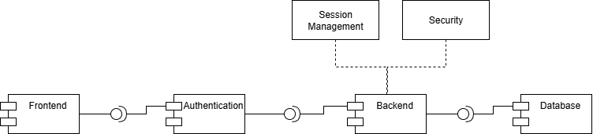
Diagram 1: High-Level Component Diagram
- Backend: Node.js with Express
- Frontend: EJS Templates + Bootstrap (assumed from static serving)
- Database: PostgreSQL
- Session Management: express-session (optionally with Redis)
- Security: Helmet, CSRF protection, Content-Security-Policy, Brute-force prevention
- Authentication: Username/password with bcrypt and optional 2FA (using Speakeasy & QR code)

Functional Module Designs
- Authentication & Security
- Login with brute-force protection
- 2FA via TOTP (Time-based OTP) with QR Code
- CSRF protection and session handling
- Secure cookie configuration
- Module: Accommodation
- Assign keys to soldiers
- Move soldiers between rooms
- Track room status (free/occupied)
- Module: Laundry
- Track laundry bag status
- Manage exchange logistics
- Generate reports on usage and nationality
- Module: Bicycles
- Bike assignment to soldiers
- Track status: Available, Rented, Late, Repair, Long Term
- Helmet tracking
- APK for Android app
- Module: Assets
- Manage asset lifecycle (add, edit, delete, write-off)
- Track asset locations (buildings/rooms)
- Upload assets via Excel
- Asset types and categories
- Reports and usage monitoring

Database Design (Simplified ERD)
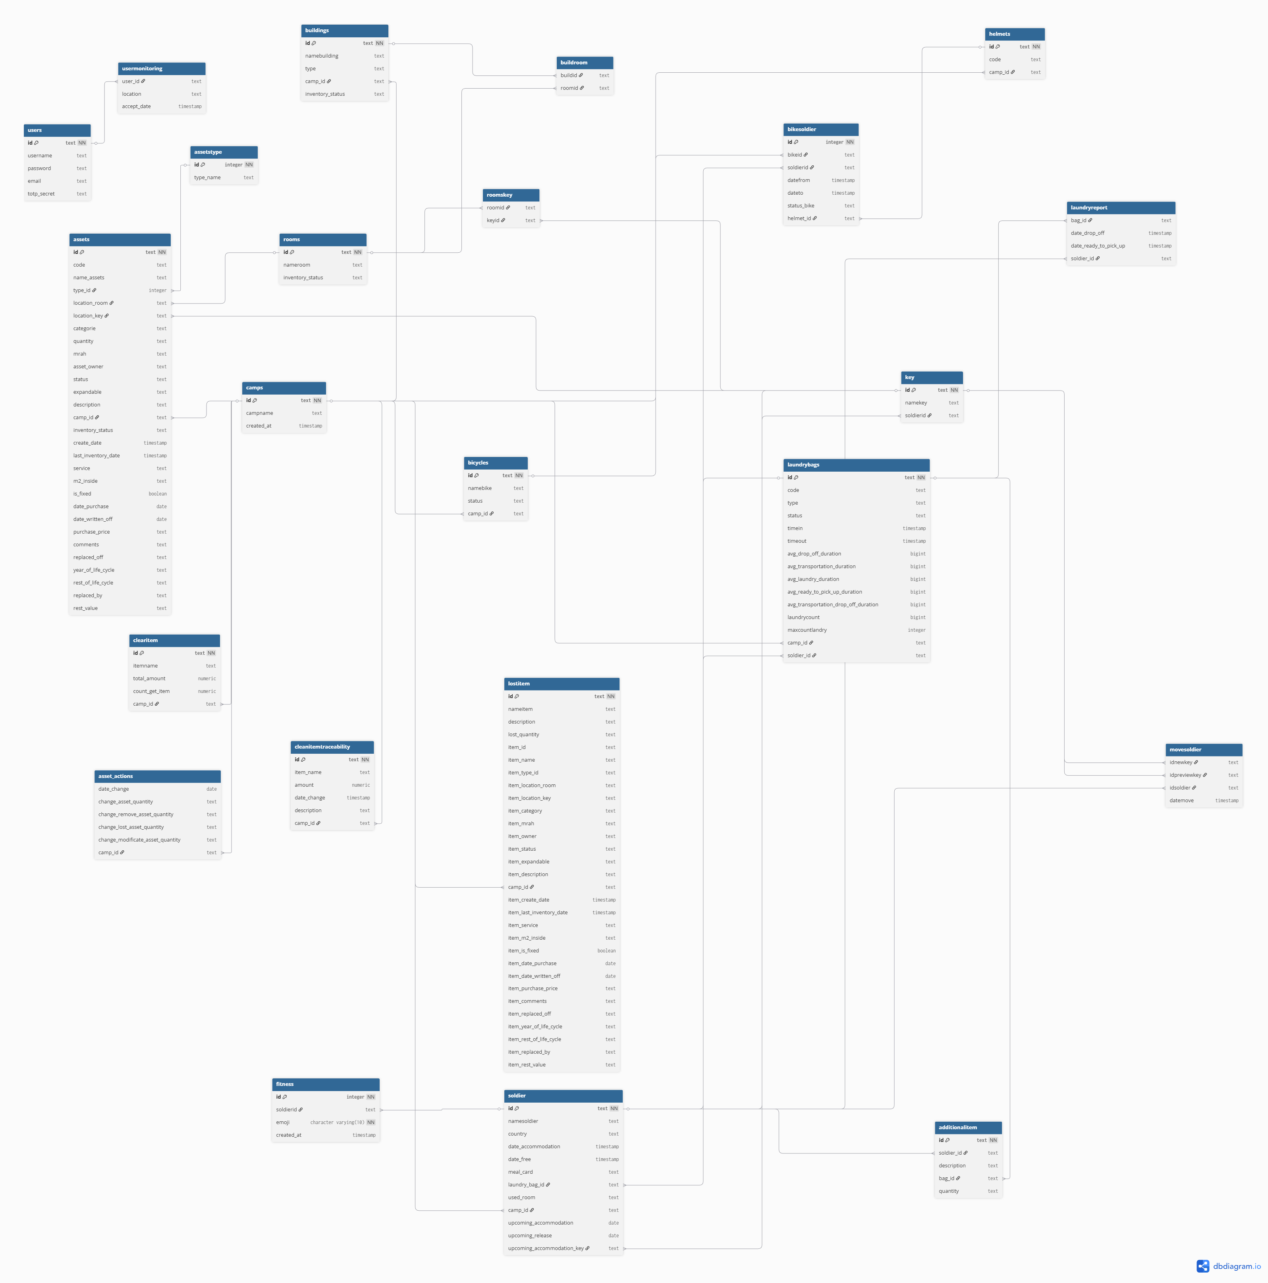
Diagram 2: Entity-Relationship Diagram

User Interface Design

Templates Rendered with EJS
- Main Page: Displays modules based on permissions
- Accommodation Page: Visual breakdown of room/building assignments
- Laundry Page: Bag tracking and statistics display
- Bicycles Page: Bike status and usage options
- Assets Page: Tabular display of asset inventory
- Login & 2FA Pages: Auth entry and QR code verification

UI Features
- Calendar display using generated HTML
- Dynamic tables for data display
- Form validation with client- and server-side checks
- Bootstrap-style layout and navigation bar (horizontal)

Permissions Model
Action | Laundry Supervisors | Accommodation Managers | Asset Managers | Field Operators with RFID/NFC devices | Admin
Access Home Page | ✔ | ✔ | ✔ | ✔ | ✔
Access Bicycles | ❌ | ❌ | ❌ | ✔ | ✔
Access Asset | ❌ | ❌ | ✔ | ✔ | ✔
Access Laundry | ✔ | ❌ | ❌ | ❌ | ✔
Access Accommodation Page | ❌ | ✔ | ❌ | ❌ | ✔
Access Help | ✔ | ✔ | ✔ | ✔ | ✔
Table 1: Permissions model

Design Considerations

Security
- CSRF protection using csurf
- Helmet middleware for HTTP headers
- TOTP-based 2FA using speakeasy
- Content-Security-Policy enforcement
- Secure password storage with bcryptjs
- Optional Redis session store for scalability

Scalability
- Session configuration supports Redis
- Modular route definitions per domain
- Joi schema validation for robust data handling

Usability
- Multi-role support with customizable navigation
- Excel import/export for bulk asset handling
- Android APK support for offline/field workers

Maintainability
- Centralized schema validations via Joi
- Clear separation of business logic and routing
- Structured error handling and monitoring

